|  |  |
| --- | --- |
| Short Title | Arousal Measures |
| Effective Date | September 4, 2013 |
| Approved by REB | September 4, 2013 |
| Version Number | 1 |

*\* Always wear personal protective equipment when making direct contact with participants\**

**Physiological Measures of Arousal**

**Background**

The following document outlines the procedures for measuring physiological arousal. Physiological arousal can occur from a variety of circumstances, whether the event that causes them is physical (ie. exertion such as exercise) or mental (ie. being frightened). The company iworx manufactures several instruments designed to measure such arousal responses. Below are common proxies for arousal with codes beside them representing specific iworx instruments.

* Galvanic Skin Response (GSR-200)
* Respiration (RM-204)
* Heart Rate (PT-100)
* Blood Pressure (BP-600)
* Temperature (TM-100)

Typically, with increased levels of arousal, any or all of these measures may increase. For further technical information, including data analysis and calibration procedures, refer to the manuals associated with each instrument, copies of which have been included in this document on pages 4 through 17, or contact the supplier at http://www.iworx.com/

**Protocol**

In the interest of inclusiveness and cultural sensitivity, what researchers will require of participants should be made as transparent as possible. In particular, during recruitment the following script should be used and should include a link to this SOP.

*"The researchers wish to be inclusive in their recruitment process. This project requires the placement of medical sensors on the head and body by a male researcher. Participants will take part individually or in pairs. If for any reason you may feel uncomfortable taking part, please contact the researcher to discuss modifications to the procedure to address your concerns. Please see a copy of the SOP describing the procedure at <link>"*

For each individual measure of arousal, the researcher should...

1). Include a diagram or pictures for the purpose of informed consent which displays where/how the instrument will be worn. See *Figure 1* on p.3 for an example.

2). Don latex free, nitrile gloves.

3). Explain the process to the participant and obtain their consent verbally prior to affixing any instruments, including what each device does and where/how it will be worn. For each instrument, the explanation and procedure is outlined below. These explanations should also be present on any written consent forms.

3a). **Galvanic skin response** sensors measure micro changes in the conductance of electricity across the surface of the skin. As people become aroused, they sweat, which increases the conductivity. The sensors will be gently strapped to any two adjacent fingers of either hand via Velcro.

3b). A **pulse plethysmograph** is a small clip on device used to measure changes in peripheral pulse. This can be used to obtain a heart rate, or when used in conjunction with a blood pressure cuff it can help to measure blood pressure. The pulse plethysmograph should be gently clipped onto any finger tip not occupied by galvanic skin response sensors.

3c). The **sphygmomanometer** (blood pressure cuff) is used to measure blood pressure and is similar to one that a physician would use. The cuff should be wrapped around the upper arm, mid-humerous, such that the sensor, as indicated by an arrow on the cuff, is directly over the brachial artery. Clothing should be removed or sleeves rolled up such that the cuff can have proper contact with the skin. The pulse plethysmograph should be attached to a finger on the same arm from which blood pressure is being taken. Inform the participant that you will be inflating the cuff, and if they should experience any discomfort to alert you immediately (at which point you will deflate the cuff completely and cease the procedure). If the participant knows their normal blood pressure, inflate to 20 mm Hg higher than their typical systolic pressure. If they do not know, do not inflate to more than 160 mm Hg. Release the pressure slowly at a rate of 10 mm Hg / second.

3d). The **respiration monitor** consists of an elasticized band with a pressure sensor meant to be worn around the torso and measures the rate and depth at which the participant breathes. The monitor should be worn over clothing, and does not necessitate the wearing of any particular clothing (i.e. loose or tight) and the fact that it is worn over as opposed to under clothing should be made clear to participants during the consent process. It should be placed below the sternum, at approximate height with the participant's elbows. It should fit snugly, but not so tight as to cause discomfort. Ask the participant if it feels comfortable.

3e). The **temperature sensor** can assess a participant's temperature in a non-invasive manner by placing a probe on the surface of the skin to measure skin temperature. Conversely, it may be placed under the nose to measure temperature changes in nasal airflow. If it is necessary, tape may be used to ensure proper attachment of the sensor. Medical grade, latex free IV tape is recommended. *Participants should be screened for*  *allergies to adhesives during the recruitment phase and the consent process, and this*  *should be verbally confirmed before placement of any tape*. If tape is required, the sensor should be placed in a location that is relatively hair free, such as the inside of the forearm, or directly behind the ear. For participants who appear to have an excessive amount of hair, tape should not be used. If a participant is wearing a head dress of any kind consider an alternative placement of the sensor. If an alternative cannot be used, ask the participant if they would feel comfortable removing their head dress. This point should also be iterated through the consent process. Be mindful of cultural and religious beliefs.

4). After each use, all equipment must be cleaned. In particular, any equipment that makes direct contact with the skin or other parts of the body should be rinsed, gently washed in warm, soapy water, rinsed once more, and finally wiped down with isopropyl alcohol and left to dry. For instruments where it is not acceptable to get them excessively wet, it may be appropriate to wipe them down with a damp cloth rather than submerge them. Examination gloves should be disposed of after each use.

*\*Note: this is not a medical diagnosis, and it should be made clear to the participants that the researcher is not a health care professional. Individual results should not be provided to participants or interpreted under any circumstances. Participants should seek the advice of a physician should they have concerns about their measurements. This should be clearly stated on the consent form.\**

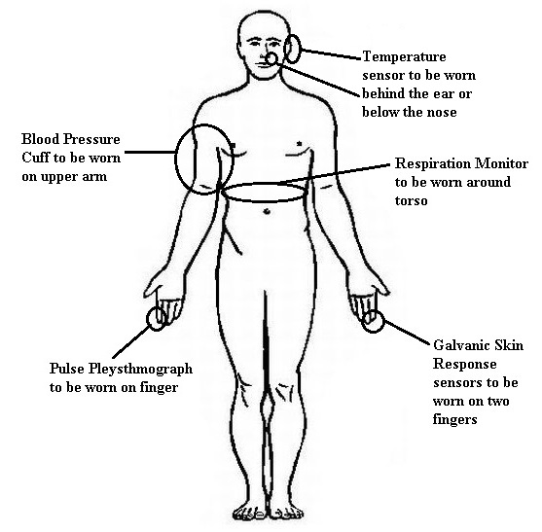

*Figure 1*. Example diagram to be included in consent process.

**BP-600 Noninvasive Blood Pressure Sensor**

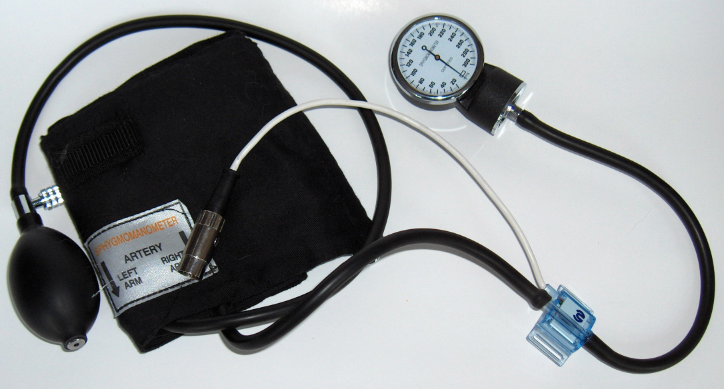

***BP-600***

**Overview**

A person's cardiac output, peripheral vascular resistance, blood pressure, and

other cardiovascular parameters change in response to the activities and events

taking place in the person's daily schedule. A device like the BP-600 Noninvasive

Blood Pressure Sensor makes it easy to study the changes in blood pressure that

take place over the course of an event or an activity. The BP-600 has two major

components: a blood pressure cuff used to occlude the flow of blood in a subject's

brachial artery; and a pressure transducer used to monitor the pressures in the cuff

that correspond to the systolic and diastolic blood pressures. The output of the

pressure transducer is a voltage that can be recorded by an iWorx data acquisition

unit and converted into units of pressure (mmHg) by calibration.

After blood flow in the subject's arm is occluded, the pressure is released from the

cuff by another student who is listening for the return of pulsatile blood flow in the

arm. The first Korotkoff sound to be heard occurs at the systolic pressure and the

last Korotkoff sound is at the diastolic pressure. To make it easier for students to

find the systolic and diastolic pressures, the output of a pulse transducer attached

to the subject's finger can be used to indicate the presence or absence of blood

flow in the arm before, during, and after the occlusion of the subject's brachial

artery.

**How It Works**

When the blood pressure cuff is placed on a subject's upper arm and inflated to a

pressure above that person's systolic pressure, blood flow to the lower arm is

occluded so that a pulse wave will not be seen when a pulse plethysmograph is

used. As pressure is released from the cuff, the output of the pressure transducer

will go down. Blood will begin to flow as the pressure in the cuff falls below the

subject's systolic pressure. The pressure at which the pulse is first seen on the

recording from the pulse plethysmograph can be identified on the recording by a

mark that labels the systolic pressure. As the pressure continues to be released

from the cuff and the output of the pressure continues to go down, the amplitude of

the pulse wave increases up to a maximum. The pressure at which the first

maximum amplitude pulse wave is seen during the release of pressure from the

cuff is the diastolic pressure.

**How to Use the BP-600**

**Equipment Setup**

Plug the DIN connector of the BP-600 into the extension cable. Plug the extension

cable into a DIN8 transducer input of an iWorx data acquisition unit or amplifier.

**Calibration of the BP-600**

1) Put the blood pressure cuff on the upper arm of the subject. Align the arrow on

the cuff over the subject's brachial artery. Place the plethysmograph on the

distal segment of the middle finger. Wrap the Velcro strap around the end of the

finger to hold the unit firmly in place.

2) Click **Record** and record the output of the BP-600 for five seconds. Type "70

mmHg" on the comment line to the right of the **Mark** button. Continue recording.

3) Increase the pressure in the cuff to 70 mmHg and press the Enter key on the

keyboard. Hold the pressure in the cuff at this level for another five seconds.

Type "140 mmHg" on the comment line. Continue recording.

4) Increase the pressure in the cuff to 140 mmHg and press the Enter key on the

keyboard. Hold the pressure in the cuff at this level for another five seconds.

5) Click the **Stop** button. Release all the pressure from the blood pressure cuff.

6) Use the **Display Time** icons on the LabScribe2 toolbar to adjust the time

displayed on the **Main window** so that the complete block of calibration data

can be viewed on the screen

7) Click the **2-Cursor** icon so that two blue vertical lines appear on the **Main**

**window**. Place one cursor on the section of the recording marked as "70

mmHg" and the second cursor on the section of the recording marked as "140

mmHg".

8) Right-click on the data area of the blood pressure channel to open its right-click

menu. Select **Units** from this menu and **Simple** from the submenu to open the

**Units Conversion** dialog window.

9) Perform a two-point calibration by selecting **2 point cal** from the pull-down

menu at the top of the dialog window. The voltages at the positions of the two

cursors are already entered on the window.

10) Change the values in the boxes to the right of these voltages to the

corresponding calibration pressures, 70 and 140. Change the units to **mmHg**.

Click **OK** and the units on the Y-axis of the blood pressure channel change.

**Using the BP-600 Blood Pressure Sensor with a pulse**

**plethysmograph**

1) Click **Record** to begin recording the subject's pulse wave and the pressure in

the cuff of the blood pressure sensor. Inflate the blood pressure cuff until the

finger pulse wave on the pulse channel disappears.

2) Once the pulse wave disappears, release the cuff pressure at the rate of 10

mmHg per second. Continue to release the cuff pressure until the aneuroid

gauge reads 0 mmHg. Click the **Stop** button.

3) Scroll to the section of data recorded while the pressure in the cuff was being

released. Use the **Display Time** icons on the LabScribe2 toolbar to display the

data that includes the reappearance of the pulse wave and its return to

maximum amplitude on one screen.

4) Click the **1 Cursor** icon on the LabScribe2 toolbar to place a single blue cursor

on the window.

5) On the pulse channel, find the first detectable pulse wave that occurs as

pressure is released from the cuff. Place the cursor over this pulse wave.

6) The pressure in the cuff during this particular pulse wave is equal to the systolic

blood pressure of the subject. Look in the upper right corner of the data window

for the blood pressure channel to find the systolic blood pressure. It is listed

next to the label **Value (V)**.

7) To the right of the cursor, the amplitude of the pulse wave increases as the

pressure in the cuff decreases. In this sequence of progressively larger pulse

waves, find the first pulse wave that has the greatest amplitude. Place the

single cursor on the peak of this pulse wave.

8) The pressure in the cuff during this particular pulse wave is equal to the

diastolic blood pressure of the subject. Look in the upper right corner of the

data window for the blood pressure channel to find the diastolic blood pressure.

It is listed next to the label **Value (V)**.

9) See the sample LabScribe2 recording on the next page. It shows the BP-600

and pulse plethysmograph channels with two cursors indicating the systolic and

diastolic blood pressures.

**Experiments**

LabScribe2 experiments using the BP-600 Noninvasive Blood Pressure Sensor

include:

 **Experiment HC-1: Blood Pressure, Peripheral Circulation, and Body**

**Position** (found in the **Human Circulation** category of the LabScribe2

**Settings** menu as **BloodPressure-BodyPosition-LS2**)

 **Experiment HC-2: Blood Pressure, Peripheral Circulation**, **and Imposed**

**Conditions** (found in the **Human Circulation** category of the LabScribe2

**Settings** menu as **BloodPressure-ImposedConditions-LS2**)

 **Experiment HC-5: Body Position, Exercise, and Cardiac Output** (found in

the **Human Circulation** category of the LabScribe2 **Settings** menu as

**CardiacOutput-LS2**)

 **Experiment HC-4: Pulse Contour Analysis** (found in the H**uman**

**Circulation** category of the LabScribe2 **Settings** menu as

**PulseContourAnalysis-LS2**)

**Technical Data and Specifications**

**SPECIFICATIONS**

Impedance <900 ohms O

Sensitivity 5µV/V/mmHg

Excitation Voltage +4VDC

Output Connector DIN8

Operating Pressure +0.50 to +300mmHg

Temperature Effect +0.25mmHg/°C

Power From DIN8 input of iWorx amplifier or A/D unit

iWorx Systems, Inc. 62 Littleworth Road, Dover, New Hampshire 03820

(T) 800-234-1757 / 603-742-2492 (F) 603-742-2455

**RM-204 Respiration Monitor**

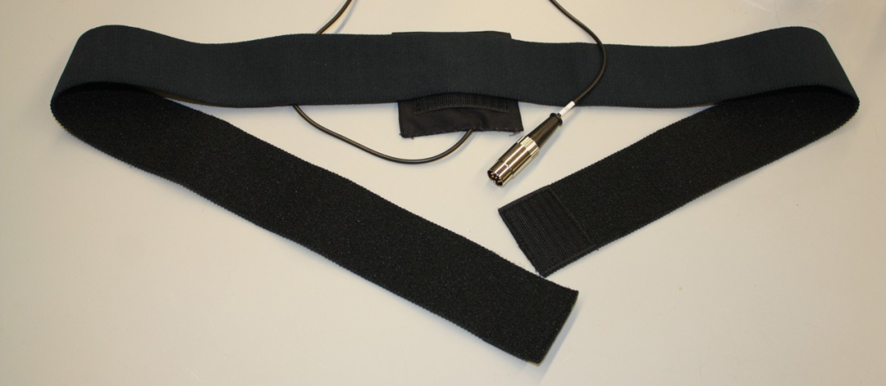

***RM-204***

**Overview**

The RM-204 Respiration Monitor is a transducer used to measure the relative

depth and frequency of breathing in a human subject during experiments where it

is impractical to monitor breathing with a spirometer. For example, the use of a

spirometer to monitor breathing during a psychological test could be a distraction

that affects the results of the test. If the subject is not familiar or comfortable with

breathing through a spirometer, the subject cannot focus on completing the test.

The RM-204 permits breathing rates and relative amplitudes to be measured

easily, accurately, and unobtrusively while the subject performs another task.

**How It Works**

The RM-204 Respiration Monitor has two components: a piezo-electric sensor that

produces a voltage in response to movement; and an elastic belt that is placed

around the chest to hold the sensor in place.

The primary driving force for pulmonary ventilation is the diaphragm, the large

muscle between the thoracic and abdominal cavities. During inhalation, the

diaphragm contracts, moves downward, and forces the abdominal wall to move

outward. The process is reversed during exhalation. The piezo-electric sensor in

the RM-204 detects the cyclic movement of the ventral body wall and generates a

voltage that is proportional to the amount of movement.

Piezo-electric sensors are devices that generate a voltage in response to motion.

When a piezo-electric sensor stops moving or is moving slowly, the voltage output

of the sensor returns to its baseline level within milliseconds. To make this motion

detector suitable for breath monitoring, the sensor of the RM-204 is fitted with a

filter that slows the return of the voltage to its baseline level. Because of the filter,

the RM-204 is able to record breath rates from 4 to 100 breaths per minute.

However, when the subject is holding his or her breath, the voltage output of the

sensor decreases very slowly. This decrease occurs because the filter cannot hold

its voltage level indefinitely and still respond to subtle changes in breathing.

**How to Use the RM-204**

**Caution: Do not bend the sensor element in the cloth pouch! Bending**

**will permanently damage the sensor.**

**Equipment Setup**

1) Plug the DIN8 connector of the RM-204 into a DIN8 transducer input of an

iWorx data acquisition unit or amplifier.

2) Wrap the elastic belt of the respiration monitor around the subject's chest at a

level that is below the sternum.

3) Place the sensor inside the belt so that the sensor is in the center of the chest

at a level that is even with the subject's elbows. The cloth pouch should be

placed inside the belt so the Velcro strip on the pouch is facing the inside of the

belt.

**Start the Software**

When using an iWorx data acquisition system with DIN8 transducer inputs or an

iWorx amplifier:

1) Open LabScribe2 by double-clicking on the LabScribe2 icon.

2) When the program opens, select **Preferences** from the **Edit** menu (or from the

**LabScribe2** menu on a Macintosh computer).

3) Select the **Channel** preferences dialog window. Name the channel to which the

RM-204 is connected. Set the **Mode/Function** for this channel to **DIN8**. Also,

set the sampling rate and display time. Click **OK**.

**Experiments**

Preconfigured LabScribe2 experiments using the RM-204 Respiration Monitor

include:

 **Experiment HS-5: Breathing Techniques and Heart Rate** (found in the

**Human Spirometry** category of the LabScribe2 **Settings** menu as

**BreathingTechniques-HeartRate-LS2**)

iWorx Systems, Inc. 62 Littleworth Road, Dover, New Hampshire 03820

(T) 800-234-1757 / 603-742-2492 (F) 603-742-24

**GSR-200 Galvanic Skin Response Amplifier**

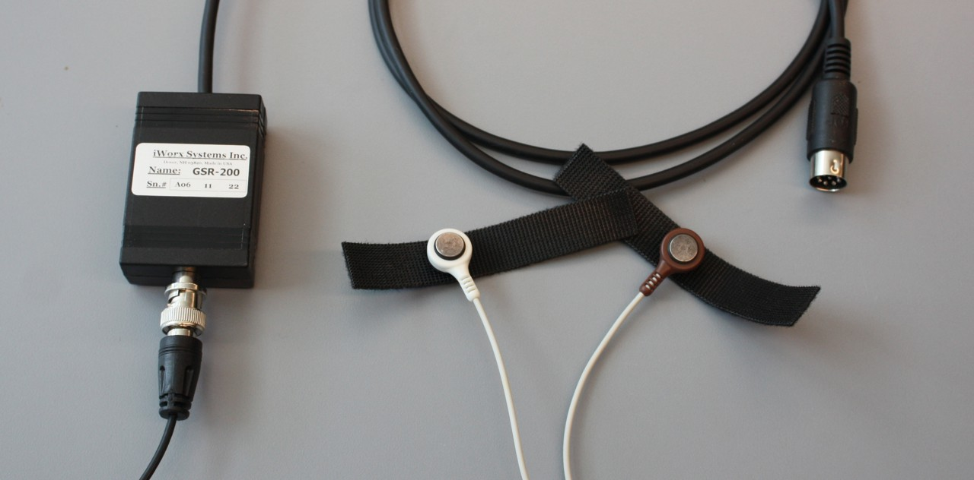

***GSR-200***

**Overview**

As a person's psychological state changes in response to events in the

environment, the electrical properties of the person's skin change due to minute

changes in perspiration. These electrodermal responses can be detected by the

GSR-200. Since human skin is a good conductor of electricity, a weak electrical

current applied to the skin can determine the resistance of the skin, or its reciprocal

which is conductance.

The GSR-200 applies a constant, imperceptible voltage between two electrodes

attached to the skin. Since the voltage is constant, the current flowing between the

electrodes is proportional to the skin conductance, or inversely proportional to the

skin resistance. The GSR-200 is able to detect the current flowing between the

electrodes and convert it to a voltage that can be recorded. Using a conversion

factor, the recorded voltage is easily converted into conductance units known as

microSiemens (µS).

**How to Use the GSR-200**

**Equipment Setup:**

Plug the DIN8 cable into a transducer input of an iWorx data acquisition unit or

amplifier.

**Start the Software:**

1) Open LabScribe2 by clicking on the LabScribe2 desktop icon.

2) When the program opens, select **Preferences** from the **Edit** menu (or from the

**LabScribe2** menu on a Macintosh computer).

3) Select the **Channel** preferences dialog window. Name the channel to which the

GSR-200 is connected. Set the **Mode/Function** for this channel to **DIN8**. Also,

set the sampling rate and display time. Click **OK**.

**Calibration and Units Conversion**

The GSR-200 is factory calibrated so that an output of 1 Volt is equal to 5

microSiemens (µS).

The basis of this conversion factor follows:

The GSR amplifier records changes in skin conductance. Conductance (G), as

expressed in units known as Siemens, is the inverse of Resistance (R):

G = 1/R

The GSR-200 applies a voltage of 200mV across the resistance being measured,

so that the Current (I) flowing across the skin from one electrode to the other is

equal to applied voltage divided by the resistance:

I = 200mv/R = 200mV*G

In the GSR amplifier, the Current (I) flows through a 1megOhm feedback resistor to

produce the Output Voltage (Vout), so that: G = V out / 0.200V * 1megOhm

Since 1 megOhm is the reciprocal of 1 µSiemen, the Conductance (G), in

µSiemens, is equal to 5 times the Output Voltage: G (in µSiemens) = 5 * Vout

Therefore, 1 Volt of output equals 5 µSiemens. This relationship along with the

Units Conversion function of the iWorx data acquisition system can be used to

convert the voltages recorded from the subject to conductance (measured in

µSiemens).

To apply this conversion factor to your recording:

1) Right-click in the recording window of the GSR-200. Select **Units** from the right-

click menu and select **Simple** from the **Units** submenu.

2) Select **2 point cal** from the pull-down menu in the upper-left corner of the **Units**

**Conversion** dialog window.

3) Enter “zero”in both the upper data boxes. Enter “1” in the left lower data box

and “5” in the right lower data box.

4) Enter the name of the units, **µSiemens**, in the **Unit Name** box. Click **OK** to

activate the unit conversion.

**Operating the GSR-200**

1) Attach the conductivity electrodes to the subject. Use the Velcro straps to

secure the metal discs to the pads of two adjacent fingers.

2) Attach the other end of the electrode cable to the BNC input of the GSR-200.

Begin recording.

3) It may be necessary to adjust the offset to zero in LabScribe2.

**Experiments**

LabScribe2 experiments using the GSR-200 include:

 **Experiment HP-2: Galvanic Skin Response and Emotion** (found in the

**Human Psychophysiology** category of the LabScribe2 **Settings**

menu as **GSR-A**)

 **Experiment HP-3: The Galvanic Skin Response, Deception,**

**Cognitive Complexity, and Vigilance** (found in the **Human**

**Psychophysiology** category of the LabScribe2 **Settings** menu as

**GSR-B**).

 **Experiment HP-8: The Galvanic Skin Response (GSR) and**

**Investigation into “Cheating”** (found in the **Human**

**Psychophysiology** category of the LabScribe2 **Settings** menu as

**GSR-Investigation**)

 **Experiment HP-7: Interference of Stimuli on Associative Tasks - The**

**Stroop Effect** (found in the **Human Psychophysiology** category of

the LabScribe2 **Settings** menu as **StroopEffect**)

**Technical Data and Specifications**

**SPECIFICATIONS**

Input Impedance 10 gigohm

Input Connector BNC

Working Voltage 200 mV

Output Connector DIN8

Output Voltage Swing +4 Volts

Bandwidth DC to 3 Hz

Noise 1 mV p-p

CMR 100dB @ 60 Hz

iWorx Systems, Inc. 62 Littleworth Road, Dover, New Hampshire 03820

(T) 800-234-1757 / 603-742-2492 (F) 603-742-2455

**PO2-100D Pulse Oximeter**

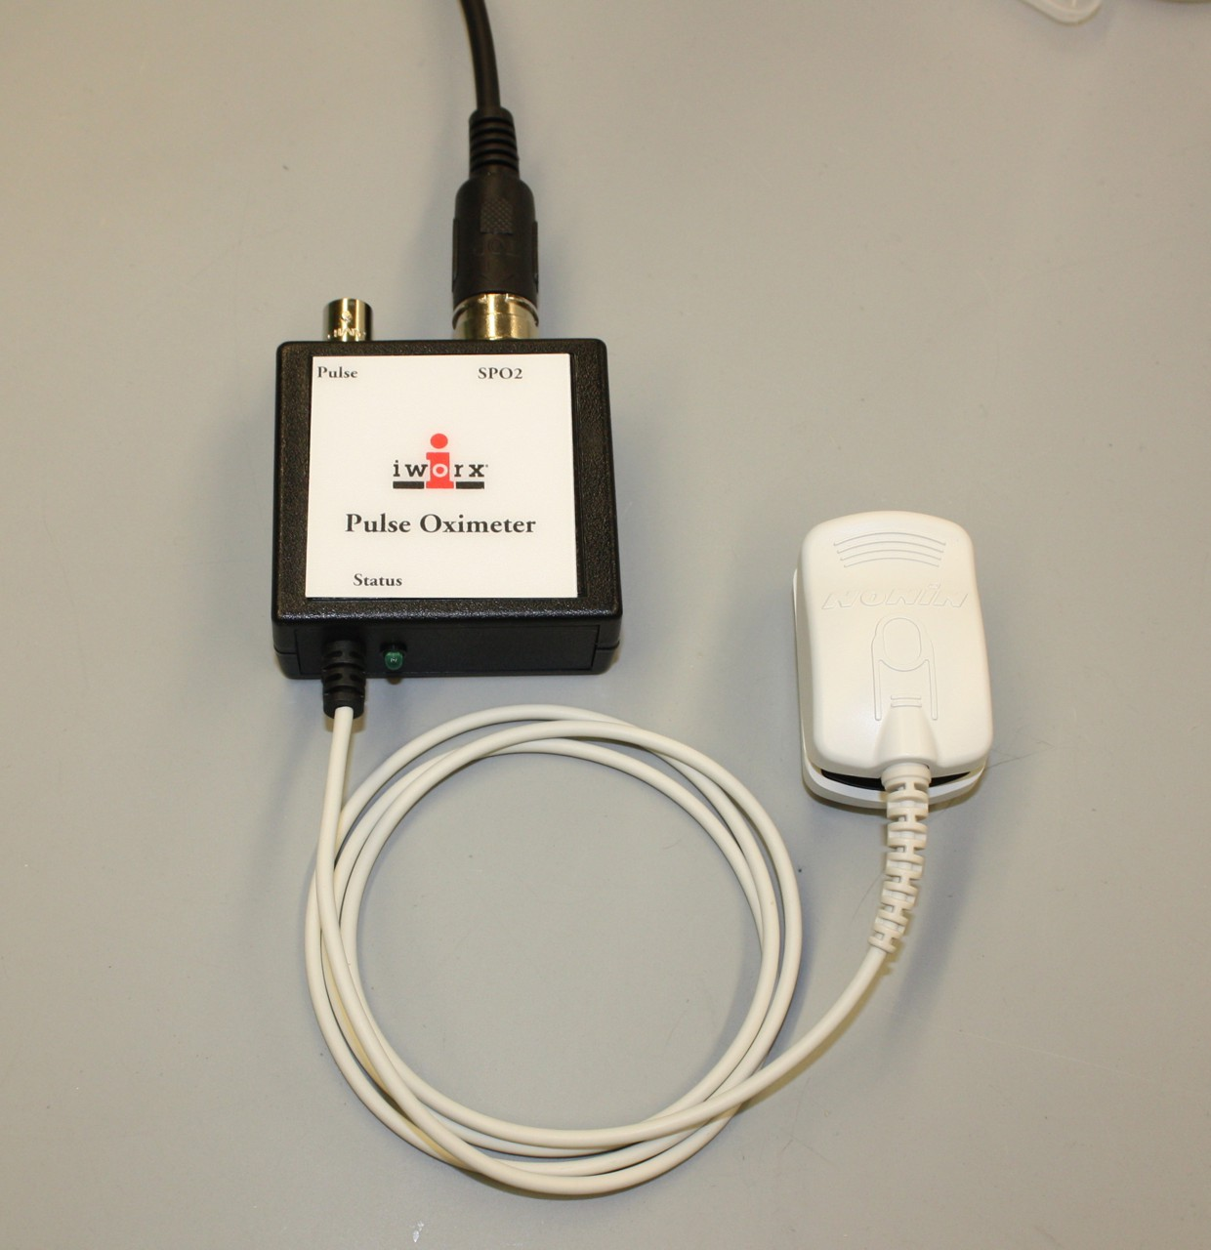

***PO2-100D***

**Overview**

One of the best methods for monitoring the cardio-pulmonary condition of a patient

in a hospital or an athlete in training is the measurement of the subject's blood

gases, oxygen, and carbon dioxide. The process is invasive and requires the use

of an expensive device known as a blood gas analyzer. An alternate method of

determining the amount of oxygen in blood is pulse oximetry. This method is easy

and noninvasive, and can be performed with a simple device like the PO2-100D

Pulse Oximeter that has a sensor that clips over the end of the subject's finger or

toe.

**How It Works**

The PO2-100D Pulse Oximeter measures the amount of oxygen in blood indirectly

by determining the oxygen saturation level (SpO2) of the hemoglobin in blood.

Hemoglobin exists in the blood in two different forms, oxygenated (oxyhemoglobin)

and deoxygenated (deoxyhemoglobin). Oxygenated hemoglobin absorbs more

infrared light and allows more red light to pass; whereas, deoxygenated

hemoglobin absorbs more red light and allows more infrared light to pass.

Therefore, the absorbance of each wavelength of light depends on the saturation

or desaturation of hemoglobin, and can be used to determine the oxygen

saturation level of the hemoglobin.

The sensor of the PO2-100D emits wavelengths of light at 600nm (Red) and

925nm (Infrared), and then detects the absorbance of those wavelengths by the

hemoglobin in the blood. Through the programming built into the PO2-100D, the

absorbance of light at each wavelength is used to determine the ratio between the

concentrations of oxygenated and deoxygenated hemoglobin in the blood. After

conversion of the output of the PO2-100D to the proper units, the level of oxygen in

the blood is expressed as the percentage of oxygen saturation. Normally, the

oxygen saturation level of blood is between 95 and 100%.

**How to Use the PO2-100D**

**Equipment Setup**

1) Plug one end of the DIN8 cable into the DIN8 connector of the PO2-100D

oximeter. Plug the other end of the same cable into a transducer input of an

iWorx data acquisition system.

2) Connect one end of a BNC-BNC cable to the BNC output of the PO2-100D and

the other end of the BNC-BNC cable to a BNC input of an iWorx data

acquisition system.

3) Clip the sensor over the end of the subject's middle or ring finger. An embossed

diagram on the sensor indicates the position of the finger within the clip. The

indicator light on the pulse oximeter will stop blinking in a few seconds when the

sensor is positioned and working properly.

**Warnings**

The PO2-100D sensor will not work properly when placed over fingernails coated

with any shade of nail polish, or over artificial nails. Also, make sure the center of

the nail is aligned under the light-emitting diode of the sensor when the clip is

placed on the finger or toe.

**Unit Conversions**

The output of the PO2-100D Pulse Oximeter is a voltage that can be converted to

a percentage. If the output is recorded using an iWorx data acquisition unit and

LabScribe2 software, the output can be converted from voltage to the percentage

of oxygen saturation in the blood using the following steps:

1) Make sure the sensor is placed on the subject's finger correctly. The indicator

light of the pulse oximeter will stop blinking after a few seconds when the unit is

working properly.

2) Click on the **Record** button in the upper right corner of the LabScribe2 **Main**

**window**. Record from the subject for about ten seconds. Click on the **Stop**

button. Two blue cursors should appear on the **Main window**.

3) Right-click on the recording area of the **Oxygen Saturation** channel to open

that channel's right-click menu. Select **Units** from the menu and **Simple** from

the submenu to open the **Units Conversion** dialog window.

4) Pull down the menu in the upper left corner of the **Units Conversion** dialog

window and select **slope & offset**. Set the **slope** equal to **10**, the **offset** equal

to **80**, and the **Name** of the units for the Y-axis equal to **%O2 Sat**. Put a check

in the box next to **Apply units to all blocks**. Click on the **OK** button.

**Heart Rate Measurements**

Since the sensor of the PO2-100D also functions as a pulse plethysmograph, the

pulse signal can be used to determine the subject's heart rate. If the PO2-100D is

used with an iWorx data acquisition unit and LabScribe software, the pulse signal

can be used to compute and display the subject's heart rate on another channel:

1) On the LabScribe2 **Main window**, open the **Edit** menu and select **Preferences**

from the menu. The **Preferences** dialog window will open onto the **Channels**

page.

2) Click on the title of an unused channel, and title the channel **Heart Rate**. Click

the **OK** button at the bottom of the window to return to the **Main window**.

3) Right-click on the recording area of the new **Heart Rate** channel to open the

channel's right-click menu. Select **Periodic** from the menu and **Rate** from the

submenu.

4) Right-click on the recording area of the **Heart Rate** channel to open the

channel's right-click menu, for a second time. Select **Set Raw Ch** from the

menu and the **Pulse** channel from the submenu.

5) While recording the pulse, heart rate, and oxygen saturation data, click on the

**AutoScale** button for the **Pulse** channel; and then click on the **AutoScale**

button for the **Heart Rate** channel to display the subject's heart rate.

**Experiments**

LabScribe2 experiments using the PO2-100D Pulse Oximeter include:

 **Experiment HE-3: Exercise, Blood Pressure, and Oxygen Saturation**

**Levels** (found in the **Human Exercise** category of the **Settings** menu as

**O2Saturation-Exercise-LS2**)

 **Experiment HC-5: Effects of Temperature on Peripheral Oxygen**

**Saturation Levels** (found in the **Human Circulation** category of the

LabScribe2 **Settings** menu as **ECG-PulseOx-LS2**)

**Accuracy**

Oxygen saturation (SpO2) data is valid across a pulse rate range from 18 to 300

beats per minute. SpO2 data is reported on a beat-to-beat basis with a maximum

update rate of three data points per second.

**Operation and Storage Environment**

The device is designed to operate in a 0 to 50 oC environment with 10-90% noncondensing humidity. The device may be stored in an environment from -30 to 50°C with 10-95% noncondensing humidity.

**Safety**

The sensor meets the IEC 60601-1 Dielectric Withstand specification.

iWorx Systems, Inc. 62 Littleworth Road, Dover, New Hampshire 03820

(T) 800-234-1757 / 603-742-2492 (F) 603-742-2455

**TM-100 Temperature Sensor**

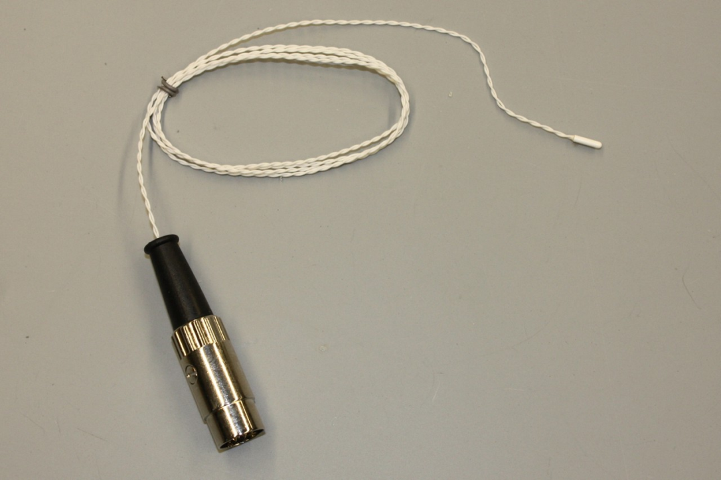

***TM-100***

**Overview**

The TM-100 Temperature Sensor is a sensor that can monitor temperatures

between 15°C above and 15°C below room temperature. The TM-100 is capable of

responding to changes in temperature within a few seconds because of its small

size (1mm x 3mm) and mass. The TM-100 is suitable for monitoring the

temperature of nasal airflow, changes in skin temperature that indicate evaporative

cooling, and changes in atmospheric temperature and temperature in

environmental chambers. Since the sensor element is water-resistant, the tip of the

TM-100 can be immersed in aqueous solutions, including saline solutions, for a

few hours.

**How It Works**

The sensor element in the TM-100 that responds to temperature changes is a

thermistor, which is a type of resistor that changes resistance with changes in

temperature. The thermistor in the TM-100 has a negative temperature coefficient

(NTC) which means that the resistance of the thermistor decreases as the

temperature goes up. Thermistors with positive temperature coefficients also exist.

Table 1 at the end of this Technical Note shows the resistances of the thermistor in

the TM-100 over a range of temperatures from 0°C to 50°C.

The thermistor in the TM-100 is wired into the circuit of the sensor as one leg of a

Wheatstone bridge. On the other three legs of the bridge circuit, selected resistors

are used to give the TM-100 a linear output over a range that is 15°C above and

below room temperature.

**How to Use the TM-100**

**Equipment Setup**

1) Insert the DIN8 connector of the TM-100 temperature sensor into a DIN8

extension cable.

2) Insert the other end of the DIN8 extension cable into a DIN8 transducer input

on an iWorx data acquisition unit or amplifier.

**Start the Software**

1) Open LabScribe2 by clicking on the LabScribe2 desktop icon.

2) When the program opens, select **Preferences** from the **Edit** menu (or from

the **LabScribe2** menu on a Macintosh computer).

3) Select the **Channel** preferences dialog window. Name the channel to which

the TM-100 is connected. Set the **Mode/Function** for this channel to **DIN8**.

Also, set the sampling rate and display time. Click **OK**.

**Calibration of the TM-100 Temperature Sensor**

1) Prepare two beakers of water, one at 10 oC, and the other at 40 C. Measure

the temperature of the cold water with a thermometer just before the TM-100

temperature sensor is placed in the beaker.

2) Place the tip of the TM-100 temperature sensor in the center of the beaker of

cold water.

3) Click the **Start** buttonon the **Main window** of the LabScribe2 software and

begin recording. Type **Calibration at <Cold Water Temperature>** on the

comment lineto the right of the **Mark** button.

4) After about twenty seconds in the cold water, the output of the TM-100

temperature sensor displayed on the recording channel should reach a stable

level. Press the Enter keyon the keyboard to mark the recording. Continue

recording.

5) Measure the temperature of the warm water with a thermometer just before the

TM-100 temperature sensor is placed in the beaker. Type **Calibration at**

**<Warm Water Temperature>** on the comment line.

6) Continue recording as the temperature sensor is moved from the cold water to

the warm water.

7) After about twenty seconds in the warm water, the output of the TM-100

temperature sensor displayed on the recording channel should reach a stable

level. Press the Enter keyon the keyboard to mark the recording. Click **Stop**

to halt the recording.

8) Select **Save As** in the **File** menu, and type a name for the file. Choose a

destination on the computer in which to save the file. Click on **Save** to save

the file.

9) Compress the data from the calibration recording onto the same computer

screen by clicking on the **Double Display Time** iconon the LabScribetoolbar.

The output of the sensor at the two temperatures should be positioned on the

same screen.

10) Click the **2-Cursor** icon and position the first cursor on the plateau of the first

temperature (~10°C) and the second cursor on the plateau of the second

temperature (~40°C).

11) Right-clickin the recording window of the temperature channel. Select **Units**

from the right-click menuand **Simple** from the **Units** submenu.

 In the **Units Conversion** dialog window, select **2 point cal** from the pull-

down menu in the upper-left corner of the window.

 Put a check mark in the box next to **Apply Units to All Blocks**.

 Notice that the voltages from the positions of the cursors are automatically

entered into the value equations.

 Enter the cold water temperaturein the corresponding box to the right of

the voltage recorded when the sensor was in the cold water. Enter the

warm water temperaturein the corresponding box to the right of the

voltage recorded when the sensor was in the warm water.

 Enter the name of the units, **o** **C**, in the box below the temperatures. Click

**OK** to activate the unit conversion.

**Operating the TM-100 Temperature Sensor**

 Once the TM-100 temperature sensor is calibrated, it can be immersed in

aqueous solutions, including saline solutions, for a few hours. **The TM-100 is**

**not designed for long-term immersion or chronic implantation.**

 The rugged Teflon jacket over the sensor can also be attached with tape or

glue to a surface to be measured.

 The TM-100 is a low impedance (~10kO) sensor, so its cable can be extended

to nearly any length without signal degradation.

**Do not attempt to measure temperatures above 125°C. Temperatures above**

**this limit will damage the sensor.**

**Experiments**

LabScribe2 experiments that use the TM-100 include:

 **Experiment HE-1: Metabolic and Thermal Response to Exercise** (found in

the **Human Exercise** category of the LabScribe2 **Settings** menu as

**MetabolicThermalResponse-Exercise-LS2**)

**Care of the TM-100 Temperature Sensor**

Since the jacket covering the element and the insulation on the wires are made of

Teflon, they may be cleaned with just about any cleaner.

**Table 1: Resistances of the Thermistor Used in the TM-100 Temperature**

**Sensor at Different Temperatures**

Temp Resistance Temp Resistance Temp Resistance

(°C) (O) (°C) (O) (°C) (O)

1 31032.1 18 13679.8 35 6531.31

2 29499.9 19 13070.4 36 6265.75

3 28052.4 20 12491.6 37 6016.47

4 26684.6 21 11941.6 38 5776.05

5 25391.2 22 11418.9 39 5546.53

6 24168.2 23 10922.0 40 5327.34

7 23011.2 24 10449.5 41 5117.97

8 21916.3 25 10000.0 42 4917.94

9 20879.8 26 9572.32 43 4726.77

10 19898.3 27 9165.29 44 4543.91

11 18968.6 28 8777.79 45 4369.33

12 18087.6 29 8408.68 46 4200.84

13 17252.6 30 8057.31 47 4040.81

14 16460.9 31 7722.43 48 3889.51

15 15710.0 32 7403.29 49 3743.17

16 14997.7 33 7098.42 50 3603.10

iWorx Systems, Inc. 62 Littleworth Road, Dover, New Hampshire 03820

(T) 800-234-1757 / 603-742-2492 (F) 603-742-2455