Short Title | GVS
Effective Date | 6 July 2011
Approved by REB | 6 July 2011
Version Number | 1
Background
Galvanic vestibular stimulation (GVS) is a technique that is used to stimulate the vestibular system via a current applied bilaterally to the external mastoid processes (bony prominence) located behind the ears. This location allows access to stimulate the 8th cranial nerve and results in a difference in signal between the two sides of the head. The volunteer subject feels the sensation of head acceleration in the direction of the cathode electrode, hence stereotypical compensatory postural adjustments are often seen in the direction of the anode electrode. GVS demonstrates the effect of modulating sensory inputs on the control of quiet standing balance and locomotion. The standard operating procedure for this technique is as follows.
- (Before beginning participation, subjects will be required to fill out a questionnaire for exclusionary criteria included at the end of this SOP) The area of skin overlying the mastoid processes (bony prominence behind the ears) (see figure 1) is cleaned with an alcohol swab to remove dead skin and lower impedance. Next, 2 self-adhesive silver/silver chloride electrodes (Ag/AgCl; KENDALL, MediTrace 130) are centered over the matsoid processes after applying electrode gel to aide in reducing electrical impedance. Lowering impedance over the stimulation area will help to maximize subject comfort when administering the current. The electrodes are secured to the subject’s head using medical tape to minimize electrode movement. One of the electrodes will act as the cathode, and the other the anode, when using a bipolar configuration. If the study involves monopolar stimulation, electrodes will be placed behind the ears, and the other polarity electrodes (anode or cathode) will be placed on the wrists of the subject.
- An isolated constant current stimulation unit (A395 Linear Stimulus Isolator, World Precision Instruments Inc, USA) is used to generate the stimulation to the subject. This can be administered either manually (through dials on the A395 stimulator, or via a computer (external device). The isolation unit is designed to deliver a constant current of any profile that is selected (sinusoid, square pulse, stochastic). The current remains constant despite altered resistance. The maximum current that can be output by the stimulator is 10mA. Typically experiments use levels of stimulation up to 3mA, although levels up to 5mA are not uncommon in the literature) A level of 3mA will not be exceeded during testing in our laboratory (Fitzpatrick et al. 2006)
- To determine the appropriate level of current for each participant a threshold is determined. This is performed by slowly increasing the amplitude of the stimulation in 0.05mA increments beginning at a very low baseline level of 0.05mA. We will be using a square wave pulse of variable intensity depending on the subject’s threshold. The subject will stand with their eyes closed (sometimes with head facing over their left shoulder – see figure 2) and their feet a comfortable distance apart with a large enough base of support to allow postural sways to occur safely. The desired amount of stimulation is reached when slight movement of the subject (usually roll of the head) is observed towards the anode electrode and the subject can verbally communicate this sensation.
- If the participant finds the stimulation level uncomfortable at any time, the level can be turned down. If the stimulation intensity reaches a level that is no longer suitable to generate a perturbation response the participant will be thanked for their time and will no longer be used for testing. This is important as their response (or lack of) may compromise the interpretation of results.
- Throughout all trials, the subject’s eyes will remain closed. During experiments there will always be a laboratory spotter available for the subject to ensure their safety. The subject will indicate when they are prepared for the next trial to begin and the GVS will then be applied at an unpredictable time during the trial.
- Once the trials are complete, the electrodes will be removed and the skin beneath them immediately swabbed with alcohol to mitigate the small possibility of an irritation due to the electrode adhesive.
- Participants will be pre-screened for sensitivity to electrode adhesive and medical tape during a pre-testing session. At this time subjects will also be excluded if they have motion sickness.
- There is no evidence to date that GVS evokes seizures. As a result the risk of seizures is minimum to null. Dizziness and nausea may be a side effect of the GVS. However, in past testing in the current laboratory these symptoms have only been experienced by “patients” who have experienced migraine headaches and cluster headaches (a particular study recruiting these particular subjects). Participants will be screened for these pre-existing conditions prior to testing.
- Participants will be required to remain in the lab until until any dizziness subsides and it is safe for them to leave.
- Procedures using stochastic vestibular stimulation (SVS) will be identical to GVS. The only difference with SVS is that different frequencies are used in the stimulation profile.

Fitzpatrick RC, Butler JE, Day BL Resolving head rotation for human bipedalism. Current Biology 16: 1509-1514, 2006

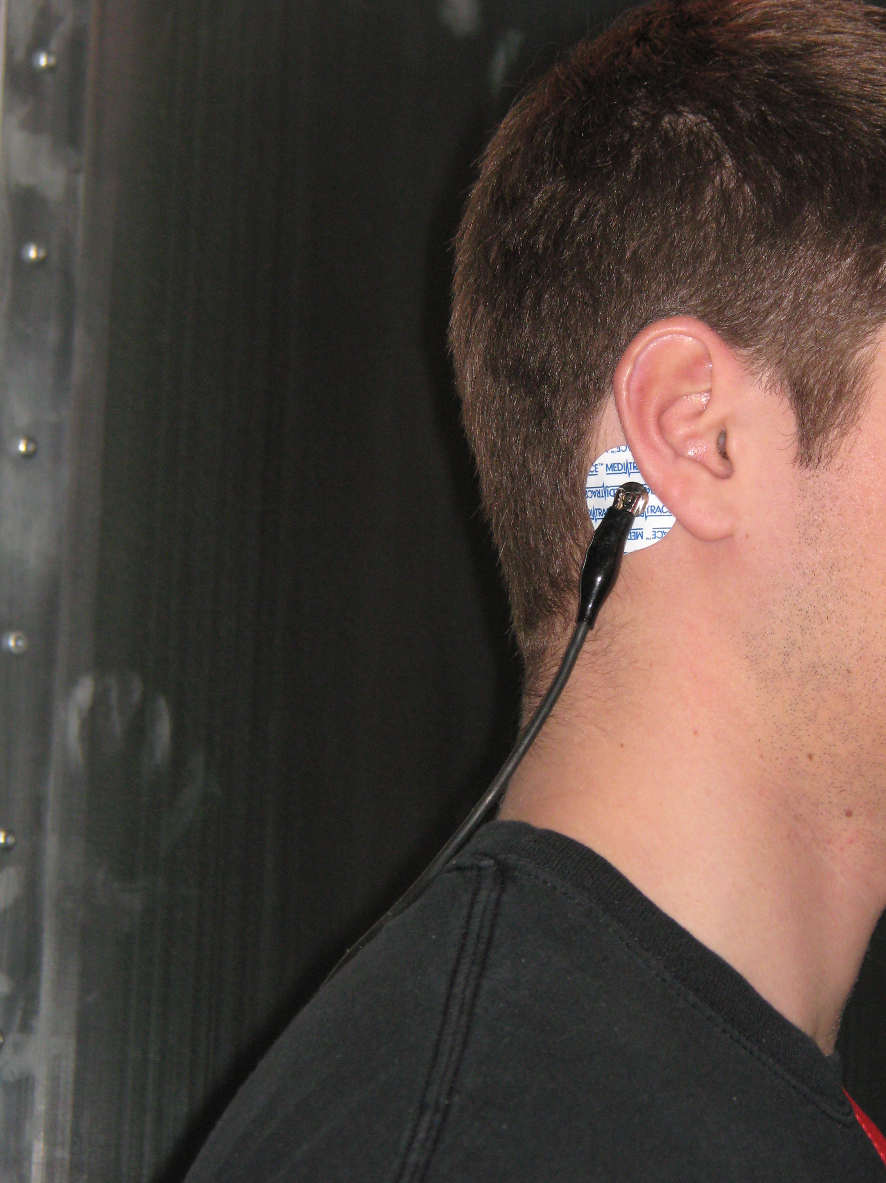

Figure 1 – Electrodes placed on mastoid processes behind ears (rear view and side view)

Figure 2 – Subject standing with arms at side eyes closed and head turned over left shoulder. There will be two spotters (not shown in picture), one in front the other behind.

GVS Questionnaire Exclusion Criteria
Name: ________________________________
Age: ________________________________
Sex: Male or Female

- Have you ever experienced vertigo or other sensations of inner ear disturbances?

If yes, please list:
_______________________________________________________________________________________________________________________________________________________________________________________________________________________________________________________________

- Do you suffer from any neurological disorders? Yes No

If so, please list: _________________________________________________________________________________________________________________________________________________________________________________________________________________________________________________________

- Do you suffer from any muscular disorders? Yes No

If so, please list: _________________________________________________________________________________________________________________________________________________________________________________________________________________________________________________________

- Do you get motion sickness? Yes No
If so, please explain:
_______________________________________________________________________________________________________________________________________________________________________________________________________________________________________________________________

- Do you suffer from diabetes? Yes No

If yes, what type (I or II) _______________________________________________________________
How long have you had Diabetes? ______________________________________________________

- Do you have a cold, ear, or sinus infection? Yes No

- Are you currently taking any medication? Yes No

If yes, please list:
_______________________________________________________________________________________________________________________________________________________________________________________________________________________________________________________________

- Is there any chance you may be pregnant? Yes No

- Are you sensitive to adhesive? Yes No

I ___________________________ certify that the information given is true, correct and complete to
(Name of participant)
the best of my knowledge.

X _____________________________________

