Short Title | Surface Electromyography
Effective Date | June 28, 2011
Approved by REB | April 6, 2011
Version Number | Version 1
Background
Electromyography (EMG) is a technique used to record electrical activity on the surface of muscles. During a volitional activity, nerve signals travel down a nerve until they reach the neuromuscular junction (connection between the nerve and muscle). Here the signals are transmitted (via neurotransmitters) to the muscle. Electrical signals then travel along the surface of the muscle, which eventually cause muscle contraction. It is these electrical signals that are recorded via surface electrodes placed on the skin overlying the muscle belly. The standard operating procedure for this technique is as follows.
- Subjects will remain either seated or standing during the entirety of the EMG procedure, depending on the requirements of the experiment.
- Subjects will be required to wear appropriate clothing that allows easy access to the area of interest on the body depending on which muscles are to be recorded from.
- The EMG procedure begins with the application of 2 standard silver/silver chloride sel-adhesive electrodes (Ag/ AgCl; KENDALL, MediTrace 130) to the skin overlying the center of the muscle bellies of the muscle of interest. These electrodes are arranged in parallel to the muscle fibres and are usually separated by 1-2cm (center to center) (see figure 1). A ground electrode (of the same brand) is used for reducing noise in the recorded signal. It is placed over a bony landmark in the region of the target muscle. Prior to application of any of the electrodes, the skin is thoroughly cleaned with an alcohol swab for several seconds to remove any dead skin and lower skin impedance, to improve the quality of the recording.
- If using the Bortec EMG system, there are 3 leads to be attached to the first muscle and two leads to each additional muscle. The green lead from the first muscle must attach to the ground electrode. If using the Grass system, each muscle will require its own ground electrode.
- Subjects will likely be required to perform both static and dynamic tasks during the experiment, and thus the leads will be fixed as to avoid any unwanted noise due to cable movement. These will be secured by taping them down to the subject using micropore medical tape.
- For the Bortec EMG system (Bortec Biomedical Ltd., CAN) there is a built-in amplifier with gain settings from 500 up to 5000 times. The gain can be set by the experimenter to improve the signal to noise ratio on the computer screen. Gain does not affect the subject, it simply changes the quality of the recording. When using the Grass EMG system (Grass Instruments, Astro-Med Inc, USA) the signal will be amplified by a LP511 EMG amplifier with the low and high frequency filter settings at 1 Hz and 10 Hz respectively.
- The computer will be turned on, and the baseline EMG recording will be checked along with the noise level. The data will be sampled at a rate of 2000Hz. The testing will be done away from any power supply outlets and overhead lights as to aide in reducing the environmental noise in the recorded signal. Also, any other electrical devices should be turned off during recording. Electrical noise will not affect the subject, but reduces the quality of the recorded signal.
- Once all of the testing is complete, the electrodes will be removed and the skin again swabbed with alcohol to reduce the minimal possibility of irritation due to the adhesive on the electrodes.
- Participants will be pre-screened for sensitivity to electrode adhesive and medical tape.

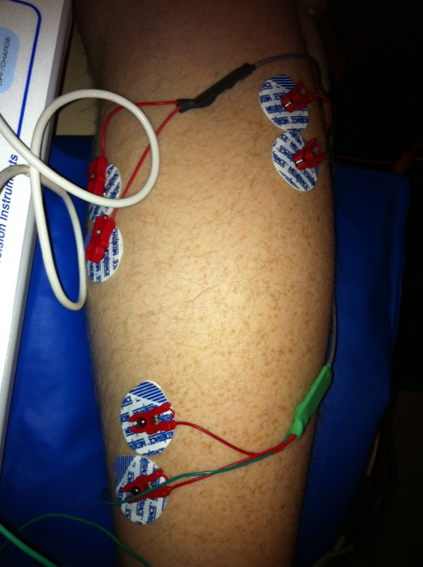

Figure 1 – three sets of 2 standard silver/silver chloride sel-adhesive electrodes (Ag/ AgCl; KENDALL, MediTrace 130) adhered to the skin overlying the center of the muscle bellies of the muscles of interest. These electrodes are arranged in parallel to the muscle fibres and are usually separated by 1-2cm (center to center)

