Short Title | Max-IIa Metabolic System
Effective Date | 24 August 2010
Approved by REB | 24 August 2010
Version Number | Version 1

Resting metabolic rate (RMR) is measured with the Max-II Metabolic System using continuous open-circuit indirect calorimetry with the help of a ventilated hood placed over the participant’s head and neck. Measurements are conducted under standardized conditions with participants lying awake but at complete physical rest. (pictured below)
.

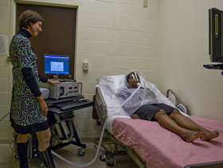

Participants undergo measurement for 30 to 45 minutes; the first 10 minutes of data are discarded to allow for acclimation to the testing environment. During the test, oxygen consumption and carbon dioxide production are measured. The test is non-invasive, simple and painless, requiring only that participants lie on a bed and breathe normally. The ventilated hood is large, clear, and lightweight. The procedure in no way interferes with participants’ breathing. The participant typically watches television during the test, to keep him/her occupied and also to prevent sleeping.
Participants must fast for this test; this involves no eating or drinking (other than water) for 12 hours prior. We provide juice boxes and granola bars after the test

Between participants, bed linen (sheet, blanket, pillow case) is changed and the inside of the ventilated hood is sterilized with a bleach wipe.

