Manipulation of blood flow through mechanical cuff restriction

ETHICS-SOP_METHODS_IP and BFR-029

# Document Sign-offs

|  | Name/ Title | Date | Signature |
| --- | --- | --- | --- |
| Prepared By | K. Thompson L. A. Vallis |  |  |
| Reviewed By | J. Burr K. Wadleigh | 18-Dec-19 |  |
| Verified By |  |  |  |
| Approved By | K. Wadleigh | 18-Dec-19 |  |

# Current Status

Approved.

# Revision information

Revision No: 4.0

Effective Date: December 18, 2019

Next Review Date: (Take date from Revision History below)

# Preamble

The NPES-REB board has agreed that in REB applications which will use blood flow restriction methodologies in healthy individuals are permissible **up to 20 minutes with exercise**.

In all REB applications, the researchers must be explicit whether the occlusion is **intermittent** or continuous and must also ensure when presenting the experimental design, that occlusion does not exceed a cumulative total 20 minutes of unilateral occlusion (i.e., maximum of minutes per limb/ per day).

Any protocol that exceeds 20-minutes of total occlusion (intermittent or continuous) will fall outside the scope of this approved SOP and must be assessed on a

study-by-study basis. Please contact the Ethics Office if you have questions.

REB protocols involving special populations where occlusions are a proposed methodology may not be supported; please contact the Manager of Research Ethics if your proposal involves both special populations and blood flow occlusion prior to the submission of any REB application for review.

# Glossary of Terms

**Ischemic preconditioning (IPC) –** Brief periods of circulatory occlusion and reperfusion induced by means of an external mechanical pressure applied to a limb of the body. The traditional use (in medicine) is for protection of local or systemic organs against subsequent bouts of ischemia or ischemic-reperfusion injury. Murry et al. (1986) first demonstrated that repeated, 5 minute periods of full arterial occlusion resulted in systemic “protection” against a subsequent, prolonged period of tissue ischemia in dog hearts. Current uses of IPC include organ protection, as well as promotion of exercise performance when used to target skeletal muscle. The most common IPC protocol meant to influence exercise performance involves three 5 minutes cycles of full circulatory occlusion and reperfusion in a peripheral skeletal muscle bed, followed by several minutes of reperfusion prior to an exercise bout, although as little as two cycles and as many as four cycles (Jean-St-Michel et al. 2011; Foster et al. 2011; Bailey et al. 2012) have been used in the literature.

**Blood flow restriction training (BFR)** – Blood flow restriction training involves decreasing blood flow (partial occlusion) to a skeletal muscle by application of a wrapping device, such as a blood pressure cuff or specially designed restrictive straps, while simultaneously performing exercise (ex. restricting blood flow to arm while performing bicep curls). Exercise protocols using blood flow restriction for resistance training ***commonly last 5-10 minutes per muscle group and for the purposes of this SOP, BFR protocols should not exceed this range without specific indication***. Blood flow restriction protocols vary depending on the specific research question being addressed. Blood flow to the active muscle can be restricted solely during active exercise, during the recovery periods following exercise, following a “to-failure” exercise bout or blood flow can be restricted continuously throughout exercise and rest. The duration and amount of occlusion to the limb typically depends on the intensity of the exercise being performed. It is not uncommon for BFR protocols to be applied for periods of ~30 minutes with incomplete reperfusion of the limb, during two-legged leg-press (Mattar *et al*. 2014) and in elderly (60-78 years of age) walking exercise training (Abe *et al*. 2010). Past studies have commonly used 70% of systolic blood pressure or anywhere from 40-80% occlusion pressure, throughout the entire duration of the exercise and rest protocol.

**Non-specific resting occlusions** – The use of sustained arterial occlusion is not only performed during IPC and BFR protocols. Complete arterial occlusion is commonly used in flow-mediated dilatation (Thijssen *et al*. 2011) and tissue oxygen saturation tests (Sakai *et al*. 2011). The duration of these tests reach ***up to 20 minutes of complete arterial occlusion*** and are commonly performed for vascular assessments in subjects with diabetes, peripheral vascular disease, acute coronary syndrome and chronic heart failure.

**Hypoxia** – Deficiency of oxygen at the level of the tissue

**Reperfusion** – Returning blood flow to normal following blood flow occlusion

**Reactive Hyperemia** – Influx of greater than normal blood flow to an area following blood flow occlusion

**Occlusion** – Blocking blood flow to a limb (partial occlusion=partial blocking of blood flow)

**Blood pressure cuff** – Inflatable cuff to collapse and then release the artery under the cuff in a controlled manner. Used to restrict or occlude blood flow to a limb for IPC or BFR

**Tourniquet** – Compressive device used to restrict or occlude blood flow for IPC or BFR

**KAATSU** – Specialized tourniquet device used specifically for BFR training

# Purpose

IPC and BFR are two methods of blood flow restriction used in the fields of rehabilitation and sports training/performance, either to augment muscular adaptation to light-load (e.g. <50% 1RM) exercise, or improve a subsequent performance.

# Scope

This SOP is intended for use with *arterial occlusion/restriction protocols* used with human subjects for the purposes of vascular assessment or vascular experimental intervention. Researchers should use this SOP to facilitate the REB application process.

# Responsibility

All researchers (trainees and PIs) investigating the effects of acute arterial restrictions must undergo a training session regarding safe and effective practice prior the commencement of their research. This must be completed with a qualified faculty advisor trained in the exercise sciences and with a recognized background in cardiovascular physiology/pathophysiology and blood flow restriction. **Documented competency must be demonstrated prior to any trainee working in blood flow restriction research without the direct oversight of the faculty member**.

Those employing IPC and BFR protocols should have:

1. A general understanding of blood pressure at rest and the blood pressure response during physical activity.
2. Read and understood the following position stand regarding the safety and efficacy of blood flow restriction techniques (*Blood Flow Restriction Exercise Position Stand: Considerations of Methodology, Application, and Safety (Patterson et al, Frontiers, 2019*).
3. Demonstrated knowledge of the background literature concerning the measurement of the lowest occlusion pressure and calculation of the required training/preconditioning pressure will be taught during the training under your faculty advisor.
4. Know how to set up and remove a tourniquet system for either BFR training or IPC.
5. Be aware of theoretical complications, signs and symptoms of an adverse event and the appropriate response to those complications.

As with any protocol involving human participants, the ability to respond to adverse events is important. Be sure that there is a response procedure outlined in the laboratory (e.g. how to direct emergency measures personal; whether and when to contact campus police). Research personnel should have basic first aid and CPR training that is up to date.

# Distribution of Copies

Ethics website

# General Exclusionary Criteria

* Renal or kidney disease or a family history of renal or kidney disease

In addition, the researchers must ask all participants these questions:

1 – Have you ever been told that you have renal or kidney disease?

2 – Do you have a family history of renal or kidney disease?

3 – Have you or anyone in your family ever had a blood clot?

4 – Have you ever been diagnosed with hypertension?

5 – Have you experienced recent infections or illness? (what is meant by recent? Typically ask things like, “In the past 30 days have you…”

6 – Have you ever been diagnosed with cerebrovascular disease e.g. Stroke?

# Procedure

## Lowest Occlusion Pressure (LOP)- arterial

When using a relative (as opposed to a standardized) pressure, the lowest occlusion pressure should be calculated as a first step. LOP can be based on thigh circumference (2) or is determined automatically using the Delfi personalized tourniquet systems, a tourniquet system with built-in Doppler ultrasound to quantify blood flow. Automatic calculations should be compared to resting blood pressure measures to ensure that they are within reason, while simultaneously confirming the absence of hypertension.

Thigh circumference and pressures required to elicit vascular occlusion are: <50 cm, 140 mmHg; 50– 55 cm, 160 mmHg (I am assuming they meant 160 and not 60); >60 cm, 200 mmHg (2). Standardizing to systolic pressure (or using a different cuff) is insufficient as cuff width, fit with the limb, or alterations in physiology (e.g. blood pressure) can change the pressure required. The cuff should be slowly inflated to progressively higher pressures while the pulse is measured distally. Depending on the limb used, a distal pulse can be monitored using any accessible measure including manual palpation, pulse oximetry, or ultrasound. For example, if the blood pressure cuff/tourniquet is being used on the arm, pulse should be monitored distally at the wrist. The LOP is at the point wherein the pulse disappears, and should be confirmed by deflating the cuff slightly below this point, and re-inflating to confirm the pulse disappearance. Alternatively, re-appearance of a pulse can be tracked during slow deflation of the cuff. The maximum inflation level with the broad cuffs is 250 mmHg beyond which pain is likely to result.

## Ischemic Preconditioning (IPC) – to be done BEFORE exercise

1. Participants are seated or supine with blood pressure cuff/tourniquet fastened snuggly around the proximal right or left thigh/arm. Blood pressure cuff/tourniquet is worn over top of a washable sleeve which is provided by the research team, which maintains cleanliness and protects against superficial soft-tissue injury. The cuff should be placed on the proximal part of the leg or arm, just under the gluteal fold, or axilla, respectively (see figures, below).
2. Pressure of blood flow restrictive device is increased to a pressure approximately 10% above systolic pressure for complete occlusion (this typically not above ~220mmHg) for 5 minutes. The pressure of the cuffs will be determined based on study design. IPC uses complete arterial occlusion, meaning pressure must exceed systolic pressure. Sham IPC procedures used as an additional trial will use pressures ranging from 10-20mmHg (no occlusion).
3. 5 minutes of circulatory occlusion is followed by 5 minutes of reperfusion, by letting pressure out of cuff
4. Steps 1-3 are repeated in to a maximum
5. Clean washable sleeve in warm water with detergent

IPC Example:

* *Blood flow occlusion – 5min*
* *Blood flow reperfusion – 5 min*
* *Blood flow occlusion – 5min*
* *Blood flow reperfusion – 5min*
* *Blood flow occlusion – 5min*
* *Blood flow reperfusion – 5min*
* *Exercise protocol (repeated sprints, cycling time trial, Wingate, etc.)*

## Blood Flow Restriction (BFR) – to be done DURING exercise

1. The blood pressure cuff/tourniquet/KAATSU is fastened snugly on the proximal portion of the working limb over a washable sleeve. If BFR training is being done on the lower limbs, blood pressure cuff/tourniquet/KAATSU will be placed on the proximal thigh. At no times should the cuff be placed more distally (at the level of the elbow or knee joint) wherein nerves are more superficial and thus prone to injury from compression and/or movement during the exercise (see figures, below)

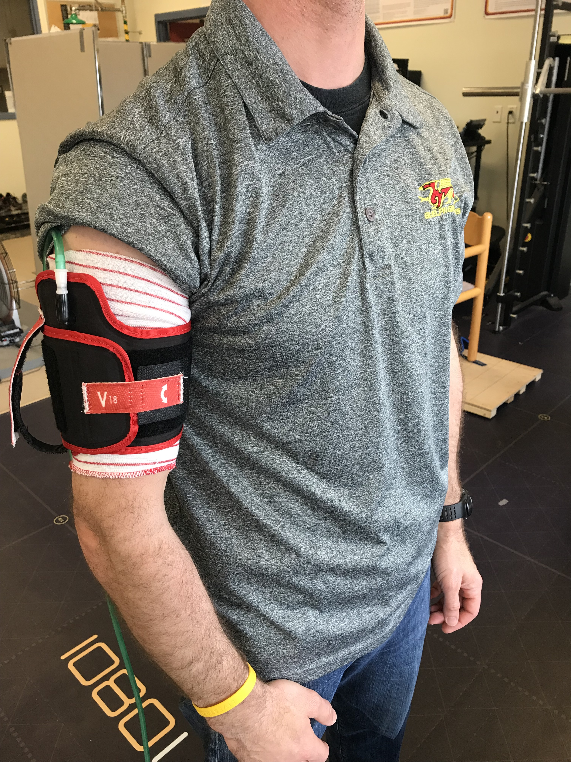 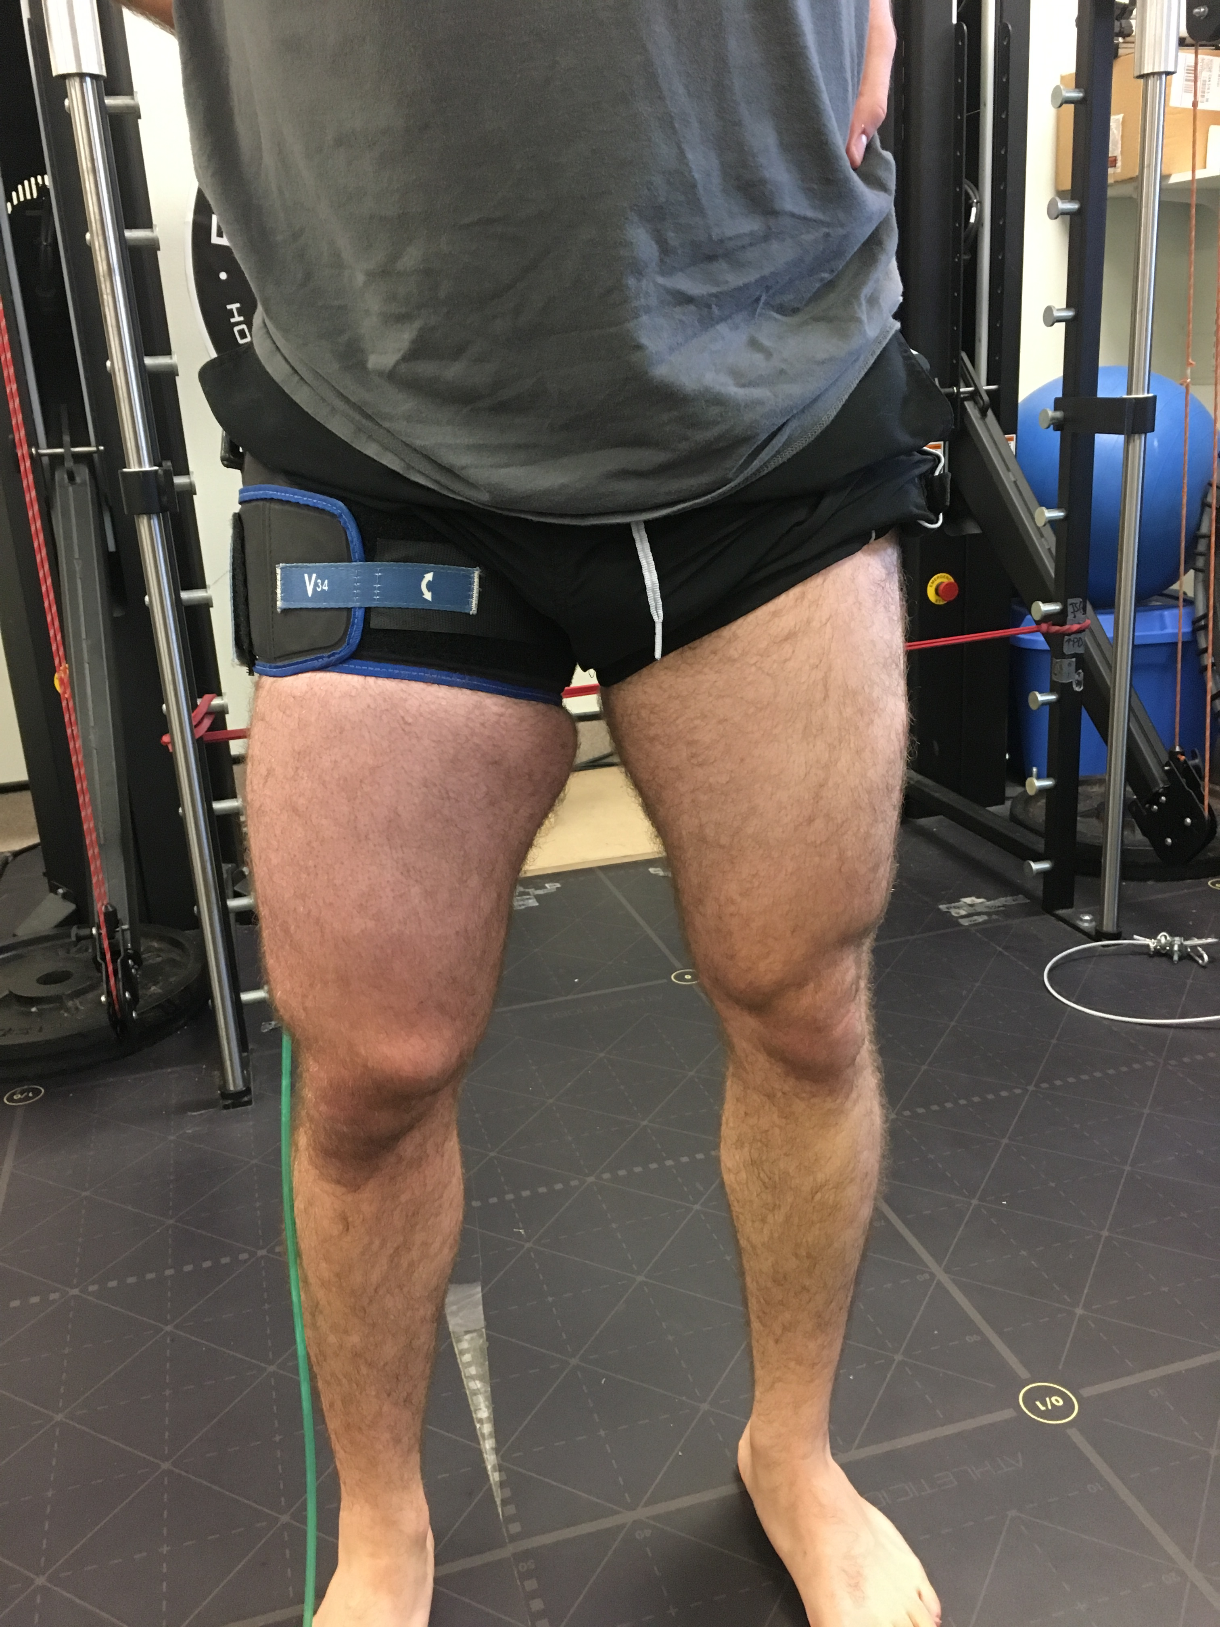

1. The pressure of the blood flow restrictive device is increased to ~180-200mmHg (*or a pressure relative to the lowest occlusion pressure, which has already been determined using the thigh circumferences provided under “Lowest occlusion pressure - arterial” or automatically using the Delfi personalized tourniquet system*). If the LOP is being used, the faculty advisor and the trainees will have previously determined the appropriate percent restriction of flow. Trainees will know how to determine LOP from the mandatory pre-study training with their supervisor. This pressure is maintained while the participant is performing the low load exercise protocol under examination and during rest periods
2. Clean washable sleeve with warm water with detergent
3. *Optional: Blood flow restrictive device increases in pressure with succeeding training days*

BFR Example: (RM= Repetition Maximum)

* *Day 1, 180mmHg, 3setsx15reps @ 30%1RM leg extensions*
* *Day 2, 190mmHg, 3setsx15reps @ 30%1RM leg extensions*
* *Day 3, 200mmHg, 3setsx15reps @ 30%1RM leg extensions*

## BFR Training Risks:

BFR is employed during training of higher performance athletes. This technique is typically performed at low exercise intensities ~30% 1RM. However, participants should be aware of the potential ***risks***.

### Rhabdomyolysis

In some cases particularly stressful exercise, with or without blood flow restriction, could cause excessive muscle trauma and breakdown, leading to a serious condition known as rhabdomyolysis. This condition is extremely rare, only occurring with extensive purposeful effort, and has quite obvious signs and symptoms including **intense muscle pain** and noticeable **darkening of urine or fatigue/fever and general malaise**, which participants will be warned about and instructed to inform the researchers (How is this to be achieved? Phone number, email, etc. Concern would be that the first priority is medical assistance.) and seek medical help should they experience any of the above. Symptoms can present anywhere from 2-12hr post exercise and peaks within 24-72hr. This type of injury only occurs in extreme cases of exercise. As of 2018, a search of the ~220 studies (Pubmed – “blood flow restriction training”) on BFR training, only two isolated **case studies** exist in which an individual performing BFR experienced rhabdomyolysis (1,5). In the first, which involved rehabilitation from a knee injury, it is notable that BFR was used for training because the participant could not undertake traditional heavy-load training, as this led to swelling of the injured leg and (very likely) was also related to the adverse event. In the second case, the participant was extremely deconditioned (a common cause following heavy exertion with or without BFR) and also had a pre-existing infection (inflammation), which is a recognized risk factor. Blood flow restriction related rhabdomyolysis has been reported to have an incidence of 0.008% (4). Like many sporting activities, however, calculation of a real risk-exposure is difficult to determine as the majority of exposures (i.e. non clinical settings) will go unrecorded, and only adverse events will be tracked. As such, adverse event estimations are likely conservative, erring on the side of caution. A brief review of the rhabdomyolysis specific literature is available in the Clinical Journal of Sports Medicine (Thompson et al, 2018 – Risks of Exertional Rhabdomyolysis with Blood-Flow Restricted Exercise Training: Beyond the Case Report.

## Exclusionary criteria

Although this very low incidence of reported cases (only two in the history of BFR training), they do give insights into important pre-disposing risk factors that should be considered exclusionary criteria during BFR studies. Specifically, this includes persons who have

* pre-existing illness or injury
* on medication related to such, even if symptoms have resolved
* persons with signs of poor vascular function (edema, exertional edema or peripheral arterial disease)
* persons who are extremely deconditioned and for whom the “low-load” training may represent a formidable or excessive exercise challenge.

For projects performed at the University of Guelph, the existence of chronic or acute illness, and injury (including cardiac, vascular, respiratory, metabolic, orthopaedic, oncologic or musculoskeletal) will be screened for using the PAR-Q+ document.

Thromboembolism

As with any exercise, there is the theoretical risk of developing a blood clot or thromboembolism, which could come loose and travel to other parts of the body (i.e. the lung) causing a blockage of flow. Compared to rest, these risks increase with the “bending” of vasculature through movement, increased intramuscular pressure and alterations in blood pressure. From current medical literature, it is recognized that when laminar blood flow is chronically disturbed the risk of clotting is increased. By design, BFR and IPC will necessarily disturb laminar flow; however, it is very unlikely that the transient interruption of flow (duration of a few consecutive minutes) would similarly increase these risks. In fact, recent literature suggests the release of an occlusive tourniquet is actually associated with an increase in the fibrinolytic system, which would work to decrease the risk of a clot.

It is recognized that the mechanical compression of unhealthy vasculature could result in the breaking/dislodgement of a pre-existing unstable plaque. **There are no reports of this occurring with BFR training or IPC but it still remains theoretically possible**.

As such, only ostensibly healthy persons with no signs, symptoms, or major risk factors (diabetes) of vascular disease should not be put under intentional vascular occlusion without appropriate medical supervision. In these cases, the **medical clearance and supervision of a medical doctor is required.**

## General Risk Management

Any researcher working with BFR or IPC should be aware of the signs and symptoms associated with an adverse event. Further, all blood flow restrictions (as noted in the above definitions) should be of a duration that falls within the typically employed durations, and are thus not without clinical and investigational precedent.

Indications of thrombosis or pulmonary embolism are:

* swelling of the limb
* leg pain or tenderness
* skin discoloration
* change in temperature perception in the affected limb
* sudden shortness of breath
* sharp chest pain
* rapid heart rate at rest (American Heart Association).

*If the Experimental protocol involves multiple site visits (e.g. Day 1, Day 2 and so on) participants will be required to rest for at least 48-hours between sessions.*

**In the event that a participant feels unwell, or experiences any signs or symptoms that could be related to an adverse event, he or she should stop all procedures or exercise and be encouraged to seek immediate medical attention. This applies whether the participant is in the laboratory, or if such feelings arise after a laboratory visit and participants should be reminded of this prior to leaving the laboratory. Research staff should reassure the participant that while the chances of an adverse event are low, the risks of not seeking appropriate care can be serious, and that early intervention (if needed) greatly reduces the potential risk. No interpretation of signs or symptoms, or speculation as to cause/prognosis should be offered. Participants should be instructed to contact the research team to follow up given any such event.**

IPC and “non-specific resting occlusions” manipulate blood flow at rest or prior to exercise rather than simultaneously. Therefore, the inclusion of the information provided for BFR training on the consent form is only precautionary. **No adverse effects have been reported from IPC**. An explanation of muscle work vs. muscle pain should still be provided on the consent form to ensure that all participants are aware of the risks.

Since arterial occlusions used in flow-mediated dilatation procedures are essentially one IPC cycle (one 5-minute occlusion), the statement above – “the inclusion of the information provided for BFR training on the consent form is only precautionary” holds true for these studies as well.

# Wording for Consent Forms

The following information should be included on consent forms of studies employing the use of arterial occlusion protocols.

## Risks of Blood Occlusion Procedures

It must be noted here that the risk of blood occlusion for experimental purposes is to some extent unknown. This procedure is used during sports training, rehabilitation, and for research, and adverse events have occurred, though they are not frequent.

## Contraindications to participation:

To reduce the likelihood of an adverse cardiovascular event persons with known to have the following conditions should refrain from taking part:

* vascular disease
* diabetes

To reduce the likelihood of thromboembolism (blood clot), persons with known to have the following conditions should refrain from taking part:

* diagnosis of Crohn’s disease
* past fracture of hip, pelvis, or femur
* major surgery within the last 6 months
* varicose veins
* family or personal history of deep vein thrombosis
* family or personal history of pulmonary embolism
* being on the oral contraceptive pill
* being pregnant

If you fall in to one of these categories, you should not participate in blood flow restriction studies. It is also conceivable that blood pressure changes in an unhealthy cardiovascular system could be poorly regulated when blood flow is manipulated. The chances of such an event, even in a high risk population are rare, but you will be asked to take a safe-exercise screening survey (PAR Q+) to ensure your safety to exercise. The PAR Q+ survey will also be used to screen for the mentioned risk factors.

During the procedure of blood flow restriction, you may experience feelings of discomfort (i.e. “this does not feel good, but it doesn’t hurt), but this should not escalate to pain. In the event that you perceive pain, you should communicate this to the research staff and the procedure will be stopped. Participants have the ability to stop any procedure at any time that it is safe to do so, and end participation in the study, regardless of the level of discomfort or pain.

If at any time [provide a reasonable time frame during which these symptoms might occur], during your lab visit or after you leave, you experience:

* swelling of the limb
* leg pain or tenderness
* skin discoloration
* change in temperature perception in the affected limb
* sudden shortness of breath
* chest, shoulder, neck, or arm pain (men) and/or poorly localized, dull discomfort (women)
* rapid heart rate at rest (American Heart Association).

You should report immediately to your health care provider or the nearest emergency room. Any and all medical concerns should thereafter be reported to the research team

# Wording for Website

Arterial occlusions, ischemic preconditioning and blood flow restriction training

# References

1. Iversen E, Rstad V. Low-load ischemic exercise-Induced rhabdomyolysis [Internet]. *Clin. J. Sport Med.* 2010;20(3):218–9.Available from: https://goo.gl/PVYujA

2. Natsume T, Ozaki H, Saito AI, Abe T, Naito H. Effects of Electrostimulation with Blood Flow Restriction on Muscle Size and Strength. *Med. Sci. Sports Exerc.* 2015;47(12):2621–7.

3. American Heart Association. http://www.heart.org/HEARTORG/Conditions/More/Symptoms-and-Diagnosis-of-Venous-Thromboembolism-VTE_UCM_479057_Article.jsp#.WBoQ0i0rLX4. Retrieved November 2, 2016.

4. Nakajima T, Kurano M, Iida H, et al. Use and safety of KAATSU training: results of a national survey. *Int J KAATSU Train Res*. 2006;2:5-13

5. Tabata, S., et al. "Rhabdomyolysis after Performing Blood Flow Restriction Training: a Case Report." Journal of strength and conditioning research/National Strength & Conditioning Association (2015).

6. Murry CE, Jennings RB, Reimer KA. Preconditioning with ischemia: a delay of lethal cell injury in ischemic myocardium. Circulation. 1986;74:1124–36.

7. Jean-St-Michel E, Manlhiot C, Li J, et al. Remote preconditioning improves maximal performance in highly trained athletes. Med Sci Sports Exerc. 2011;43:1280–6.

8. Bailey TG, Jones H, Gregson W, et al. Effect of ischemic preconditioning on lactate accumulation and running performance. Med Sci Sports Exerc. 2012;44:2084–9.

9. Foster GP, Westerdahl DE, Foster LA, et al. Ischemic precon- ditioning of the lower extremity attenuates the normal hypoxic increase in pulmonary artery systolic pressure. Respir Physiol Neurobiol. 2011;179:248–53

10. Thijssen DH, Black MA, Pyke KE, et al. Assessment of flow-mediated dilation in humans: a methodological and physiological guideline. *Am J Physiol Heart Circ Physiol*. 2010;300(1):H2-12.

11. A novel system for transcutaneous application of carbon dioxide causing an “artificial Bohr effect” in the human body." *PLoS One* 6.9 (2011): e24137

# Revision History

| Revision # | Reviewer | Reason | Date Last Reviewed | Next Review Date |
| --- | --- | --- | --- | --- |
| 2.0 | K. Wadleigh | Review of risks for 20-minute occlusion | 18 Dec 19 | 18 Dec 2020 |
| 1.0 | S. Auld | Original |  |  |

# Review Cycle

Annual.

# Appendix

N/A